Refs:

* <https://www.freecodecamp.org/news/svm-machine-learning-tutorial-what-is-the-support-vector-machine-algorithm-explained-with-code-examples/>
* <https://towardsdatascience.com/https-medium-com-pupalerushikesh-svm-f4b42800e989>
* https://ankitnitjsr13.medium.com/math-behind-support-vector-machine-svm-5e7376d0ee4d

SVM: find a separating line or hyperplane between data of 2 classes -> supervised learning method

SVM algorithms:

* find the points closest to the line from both the classes -> these points are called support vectors
* compute the distance between the line and the support vectors -> called margin -> our goal is to maximize the margin

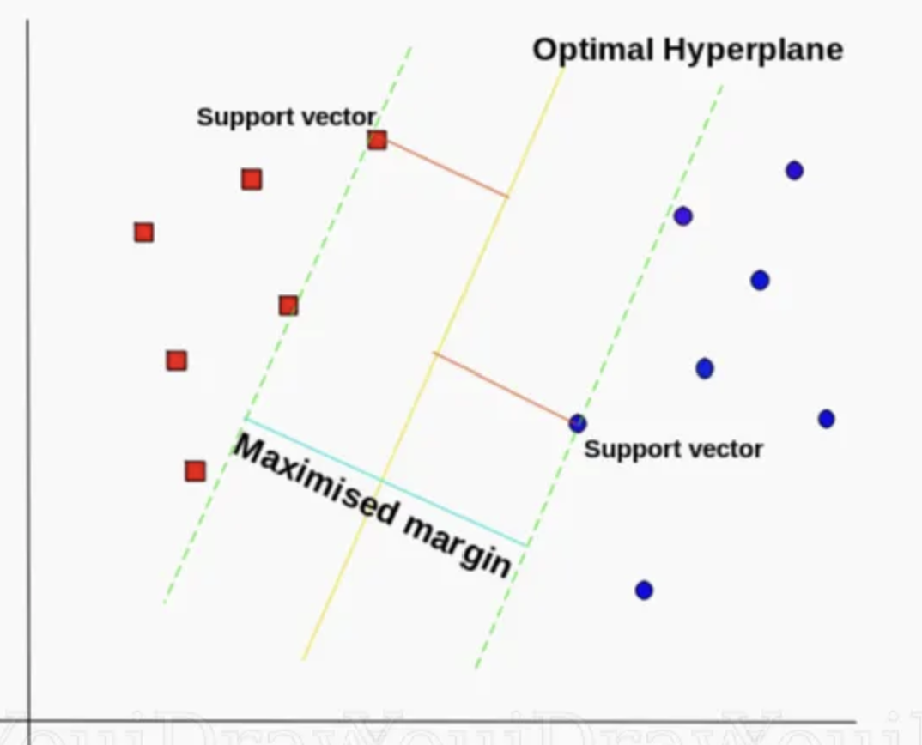

Hyperplane in an n-dimensional Euclidean space is a flat, n-1 dimensional subset of that space that devides the space into 2 disconnected parts.

Tuning parameters c: controls the trade off between the smooth decision boundary and classifying training points correctly.

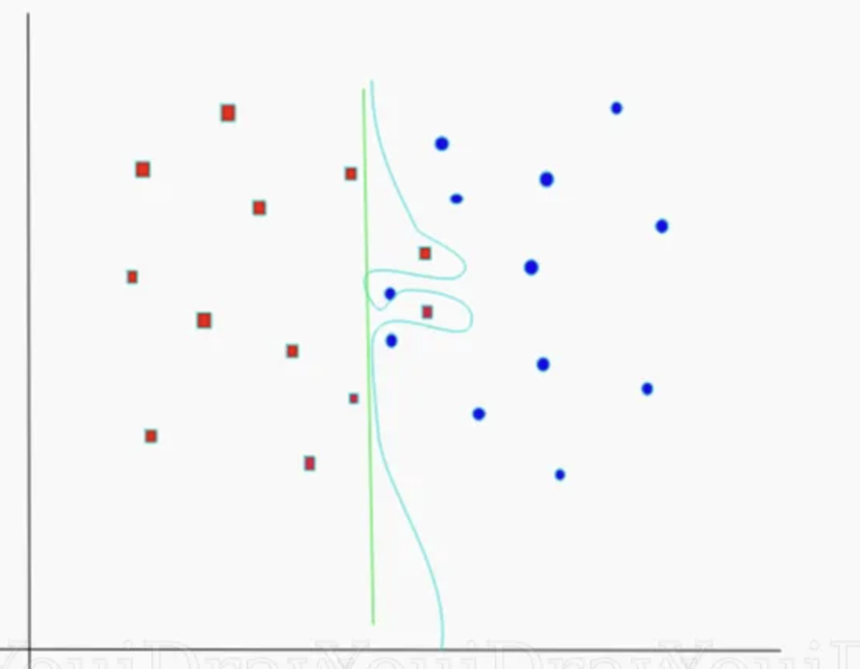

c-green < c-blue, but can cause overfitting

Gamma

Machine learning algorithms = math equations -> so they have cost functions, weight values and parameters